Project Design Phase-II
Data Flow Diagram & User Stories
Date | 3 October 2026
Team ID | SWTID-2026-9505
Project Name | Implement Client Script & UI Policy (Incident) - ServiceNow
Maximum Marks | 4 Marks
Data Flow Diagrams:
A Data Flow Diagram (DFD) is a traditional visual representation of the information flows within a system. A neat and clear DFD can depict the right amount of the system requirement graphically. It shows how data enters and leaves the system, what changes the information, and where data is stored.
Example: (Simplified)  - User opens a new Incident form in ServiceNow and enters the incident details.  - User sets Impact to 1 - High; the UI Policy makes Assigned To mandatory and the onChange script sets Urgency to High.  - The form shows an info message so the user knows what changed automatically.  - On Submit, the onSubmit script validates the form and blocks incorrect data with a message.  - Valid records are saved in the Incident table; list edits are checked by the onCellEdit script.  - The Administrator configures the UI Policy and client scripts that drive these rules. | Example: DFD Level 0 (Incident form validation)  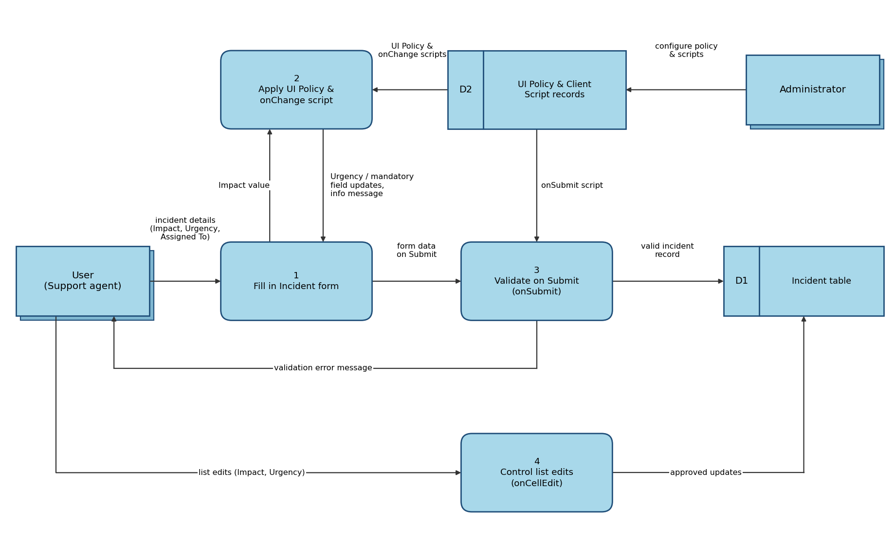

User Stories
Use the below template to list all the user stories for the product.
User Type | Functional Requirement (Epic) | User Story Number | User Story / Task | Acceptance criteria | Priority | Release
Support Agent (Incident user) | UI Policy | USN-1 | As a support agent, when I set Impact to 1 - High, I am required to fill in Assigned To so that I do not skip it. | Assigned To becomes mandatory and the form cannot be saved without it | High | Sprint-1
 |  | USN-2 | As a support agent, when I change Impact back from High, the extra controls are removed (Reverse if false). | Assigned To is no longer mandatory when Impact is not High | Medium | Sprint-1
 | Client Script (onChange) | USN-3 | As a support agent, I want Urgency to be set to High automatically when Impact is High. | Urgency changes to High and an info message is shown on the form | High | Sprint-1
 | Client Script (onSubmit) | USN-4 | As a support agent, I get a clear message and the form is not saved when the entered data is incorrect. | Submit is blocked with an alert message; the record saves when the data is correct | High | Sprint-2
 |  | USN-5 | As a support agent, I want Medium and Low impact incidents to behave normally. | Urgency is not forced and no extra checks appear when Impact is not High | Medium | Sprint-2
 | Client Script (onCellEdit) | USN-6 | As a support agent, when I edit Impact or Urgency in the list view, the same rules are checked. | Invalid list edits are rejected; valid edits are saved | Medium | Sprint-2
Administrator | Configuration | USN-7 | As an administrator, I can create and activate the UI Policy and client scripts on the Incident table. | The UI Policy is active and the scripts are listed under System UI > UI Policies and Client Scripts | High | Sprint-1
 | Testing | USN-8 | As an administrator, I can test the configuration with different Impact values before release. | Behaviour matches the expected result for High, Medium and Low impact | Medium | Sprint-2
Incident Manager | Reporting | USN-9 | As an incident manager, I can rely on consistent Impact and Urgency values in incident reports. | No High impact incident has a mismatched Urgency in the incident list | Low | Sprint-3

